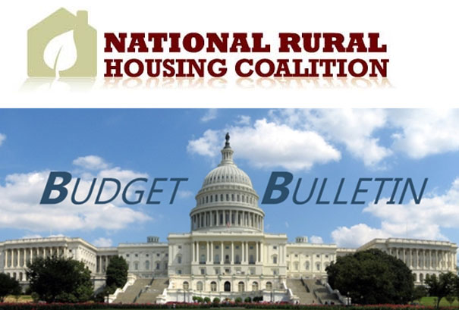
Vol. 17, No. 30 | September 10, 2014

Senate Confirmation Hearing: Lisa Mensah

This morning, the Senate Agriculture Committee held a hearing to consider the nomination of Ms. Lisa Mensah to be Under Secretary for Rural Development at USDA. You can read her testimony here.
It is fair to say that rural housing was likely the most discussed issue of the day. Senator Leahy (D-VT) asked Ms. Mensah what, in her opinion, was the Department's strategy on housing, especially in the context of disproportionate cuts to Rural Development programs. He noted that since 2010, USDA has proposed $1 billion in cuts to rural housing, water/sewer, and business programs.
Senator Boozman (R-AR) asked about the Rural Definition issue and its impact in his state, urging Mensah to commit to ample time for public comment and collaboration with stakeholders before making any determinations on eligibility.
Both Senators Walsh (D-MT) and Hoeven (R-ND) spoke about the energy boom in their states and the increased need for housing opportunities.
Throughout the hearing, Ms. Mensah spoke about her strong support for housing as a critical tool for ensuring economic prosperity in rural America. She noted that for many Americans, especially those in rural areas, a home is the largest asset they will buy in their lifetime. Homeownership is also key to building wealth and greater economic security because families can use the equity in their homes to build credit and finance their children's educations.
Ms. Mensah also reiterated many key themes of the Administration, including strengthening partnerships with private entities and foundations and working across industry silos.
Consideration of her nomination will now head to the Senate floor. However it is unclear whether her nomination will be confirmed prior to Congress's recess for the November elections.
Thank you for your support,
Sarah Mickelson

